IHE Change Proposal

Tracking information:
IHE Domain | PCC
Change Proposal ID: | CP-PCC-xxx
Change Proposal Status: | Submitted
Date of last update: | Nov 21, 2012
Person assigned:

Change Proposal Summary information:
Contradictory Values for XDS codes in EDES and PCC TF 2 (Final Text)
Submitter’s Name(s) and e-mail address(es): | Steve Moore, moores@mir.wustl.edu
Submission Date: | Nov 21, 2012
Integration Profile(s) affected: | CTNN, EDPN, NN, TN
Actor(s) affected: | Content creator
IHE Technical Framework or Supplement modified: | PCC TF 2 (FT), EDES Supplement
Volume(s) affected: | Volume 3

PCC TF 2:
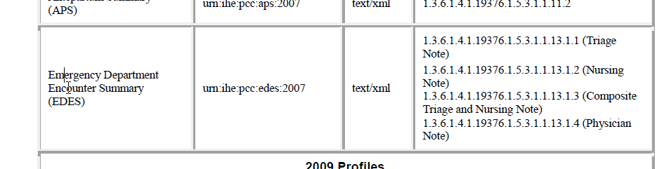

EDES Supplement
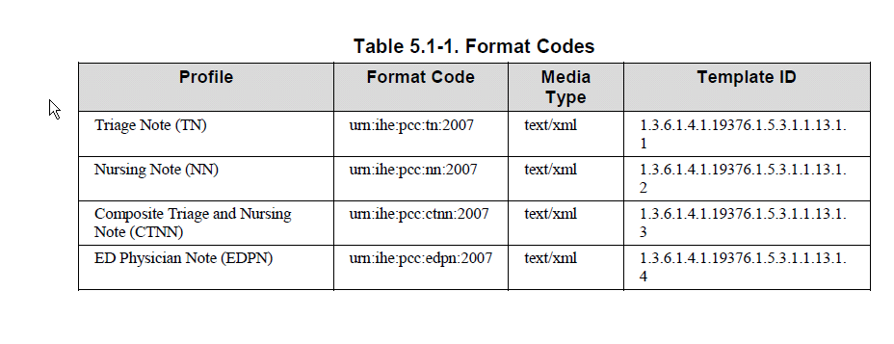
Plan – going forward is one profile = one format code. Search can be done with the format code and type code to get more granularity.

Replace all Format Codes in Table 5.1-1 with urn:ihe:pcc:edes:2007

